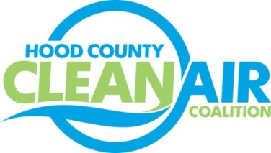
Meeting: Thursday, February 2, 2017
Neely House
304 East Rucker Street, Granbury, Texas 76048
8:30-10:00 a.m.

Agenda

- Call Meeting to Order
- EPA Updates – Randy Pitre
- Regional Updates – Chris Klaus
  - Air Quality Funding Opportunities: www.nctcog.org/aqfunding
  - Notice of Public Hearing and Extension of Comment Period: Implementation of the 2015 National Ambient Air Quality Standards for Ozone. Information at https://www.gpo.gov/fdsys/pkg/FR-2016-12-19/html/2016-30365.htm.
  - New DFW Clean Cities Website: www.DFWCleanCities.org
  - DFW Clean Cities Annual Reporting: Due March 1
- Local Updates – Michelle McKenzie
  - Review of January Meeting Summary
  - Review of Projects
    - Monthly Budget Review for December
    - Status of Projects FY 16/17
  - Reports
    - Air North Texas Meeting
    - Ozone Advance Webinar: IdleBox Idle Reduction Resources
    - Regional Texas Ozone Advance/ Nonattainment Areas Conference Call
  - Tax Filing
5.) Discussion
6.) Adjourn

